NAME : MOHAMMED FAZIL
BATCH : DAF9
ASSIGNMENT 5 : DDL COMMANDS AND CONSTRAINTS

MySQL Assignment – DDL Commands & Constraints

- Table Creation (CREATE): Write the SQL statements to create a database named “employee” and the following tables based on the provided schema:
⦿ Departments ⦿ Location ⦿ Employees

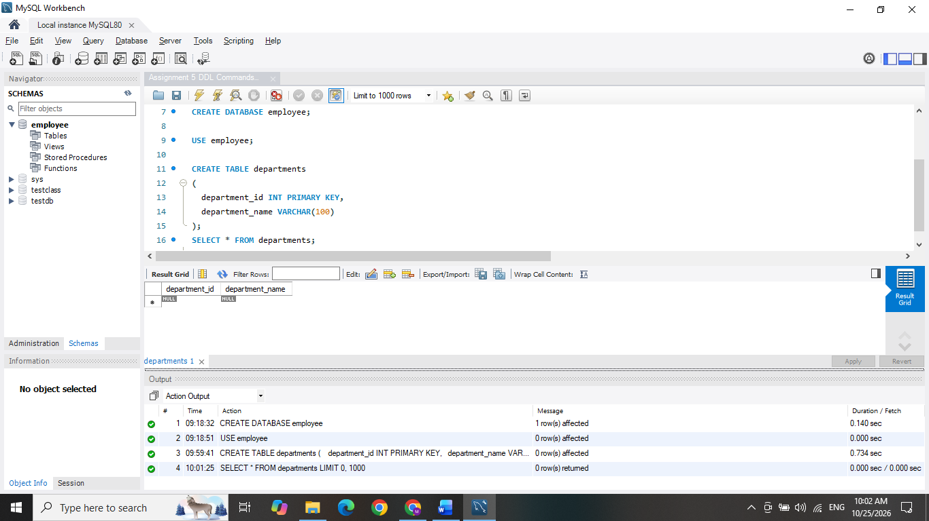

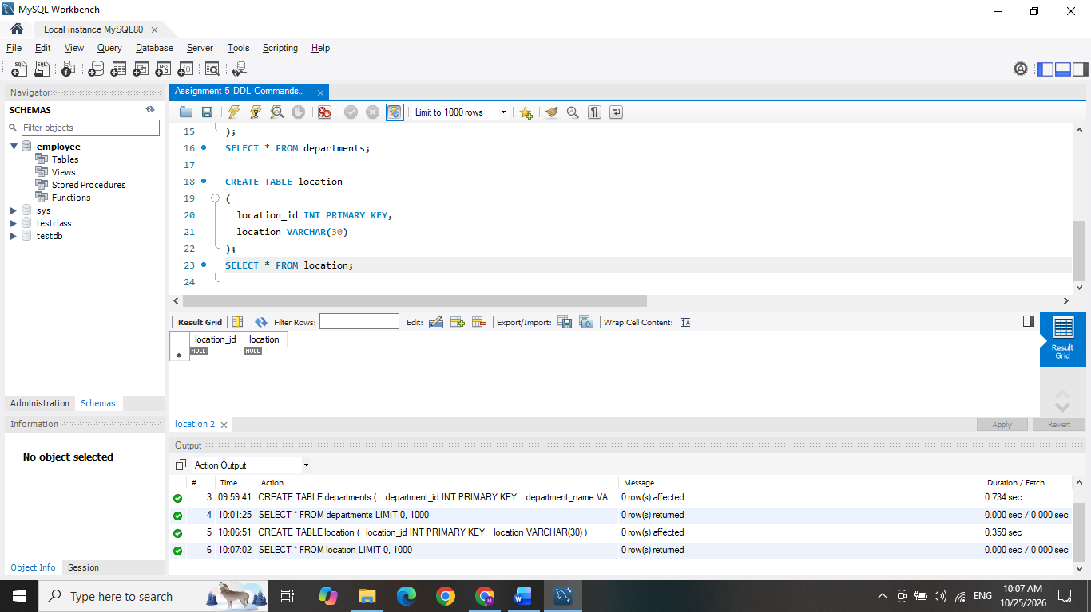
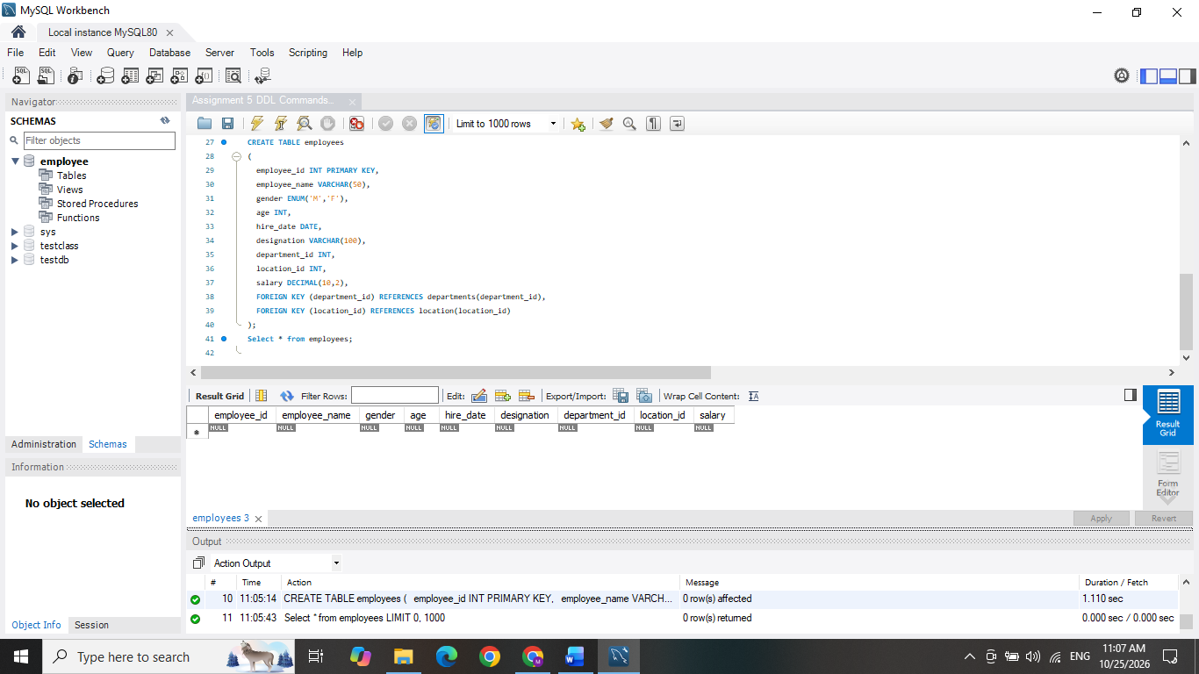

- Table Alteration (ALTER): Consider the following scenarios and write the SQL statements to alter the structure of the tables accordingly:
⦿ Add a new column named "email" to the Employees table to store employee email addresses.

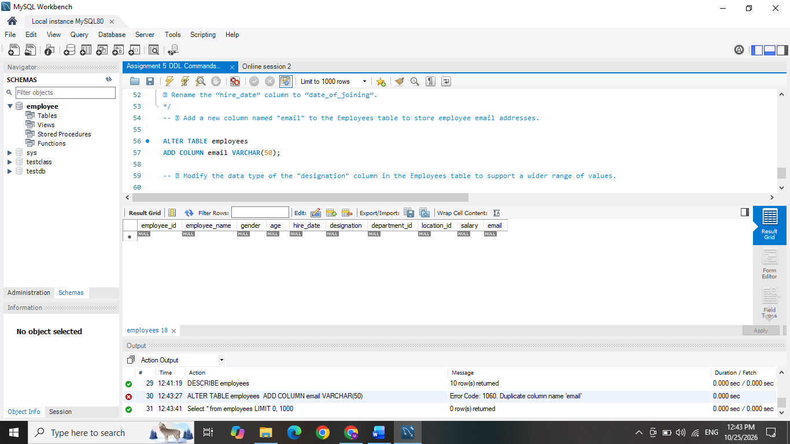

⦿ Modify the data type of the "designation" column in the Employees table to support a wider range of values.
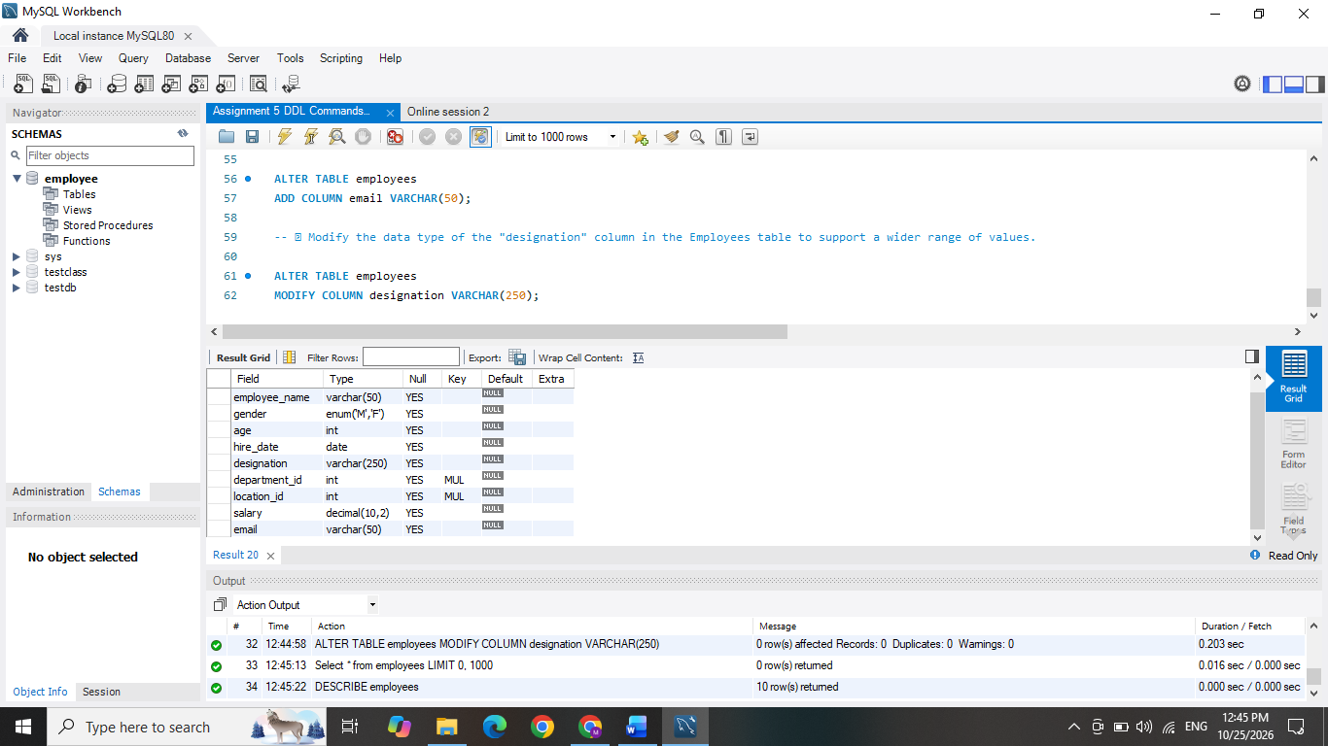

⦿ Drop the “age” column from the Employees table.

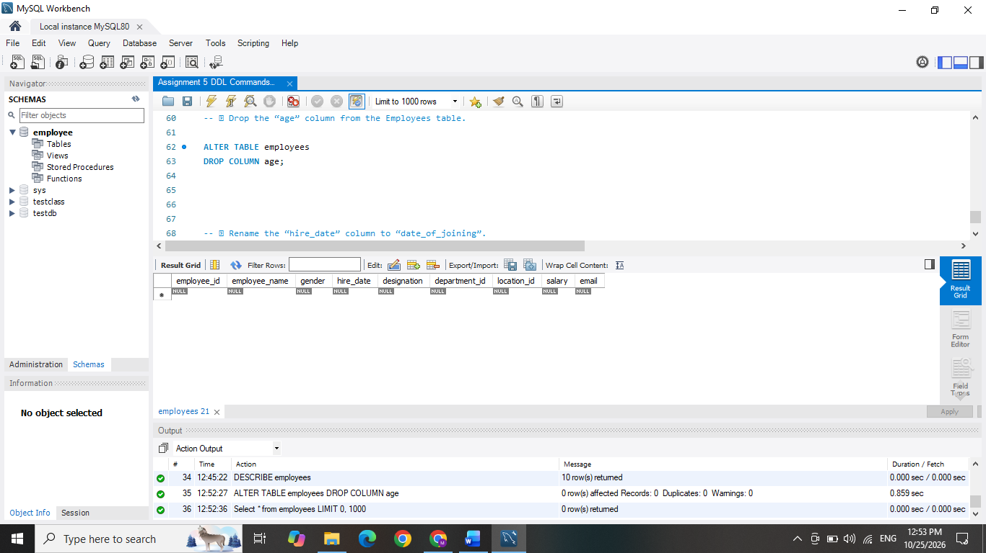

⦿ Rename the “hire_date” column to “date_of_joining”.

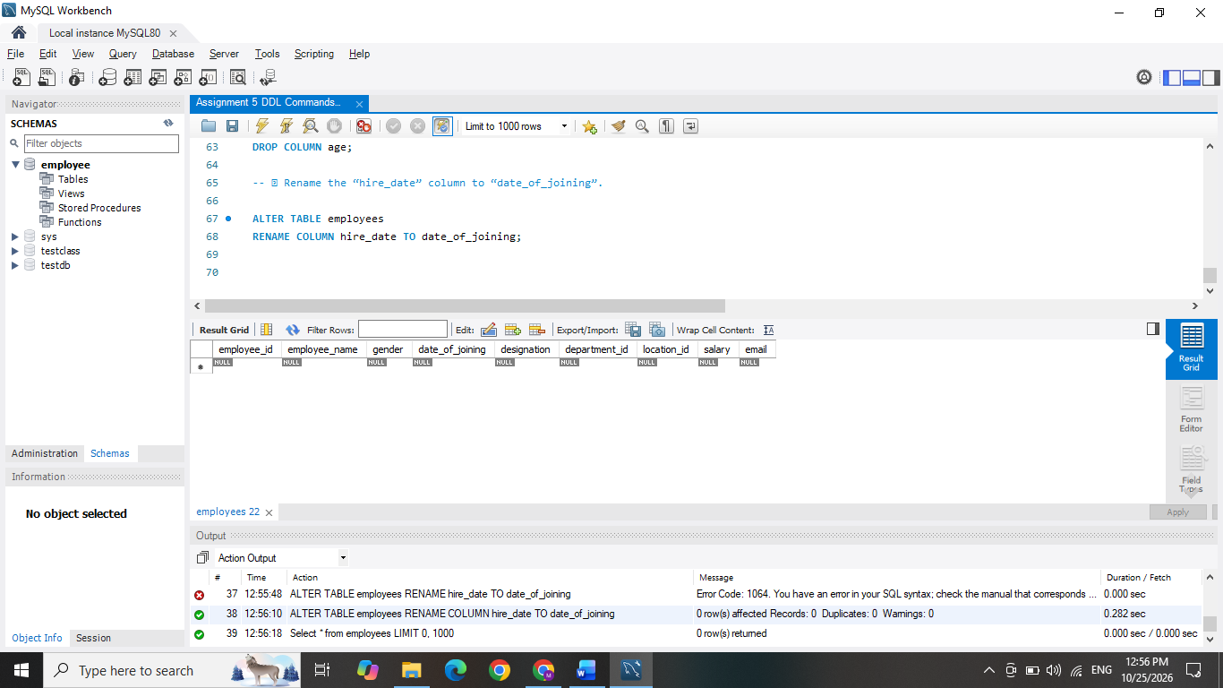

- Table Renaming (RENAME): Rewrite the SQL statements to rename the following tables:
⦿ Rename the "Departments" table to "Departments_Info".

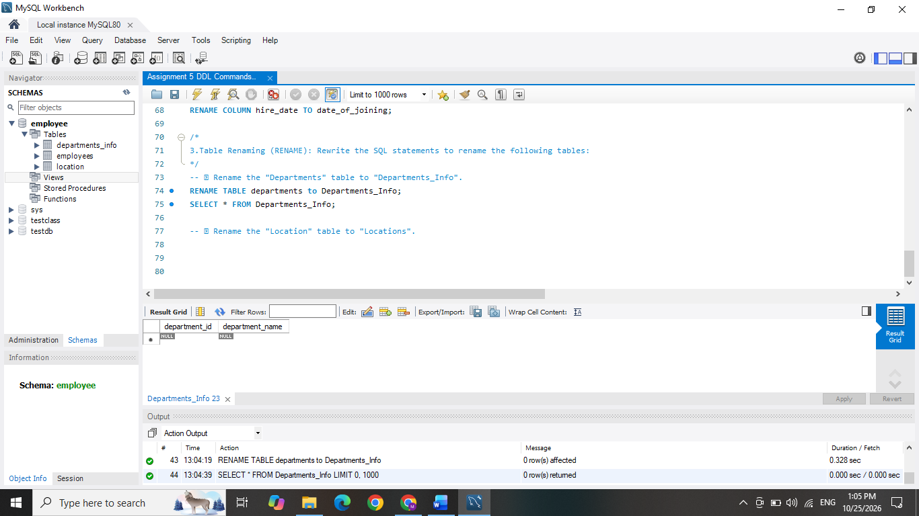

⦿ Rename the "Location" table to "Locations".

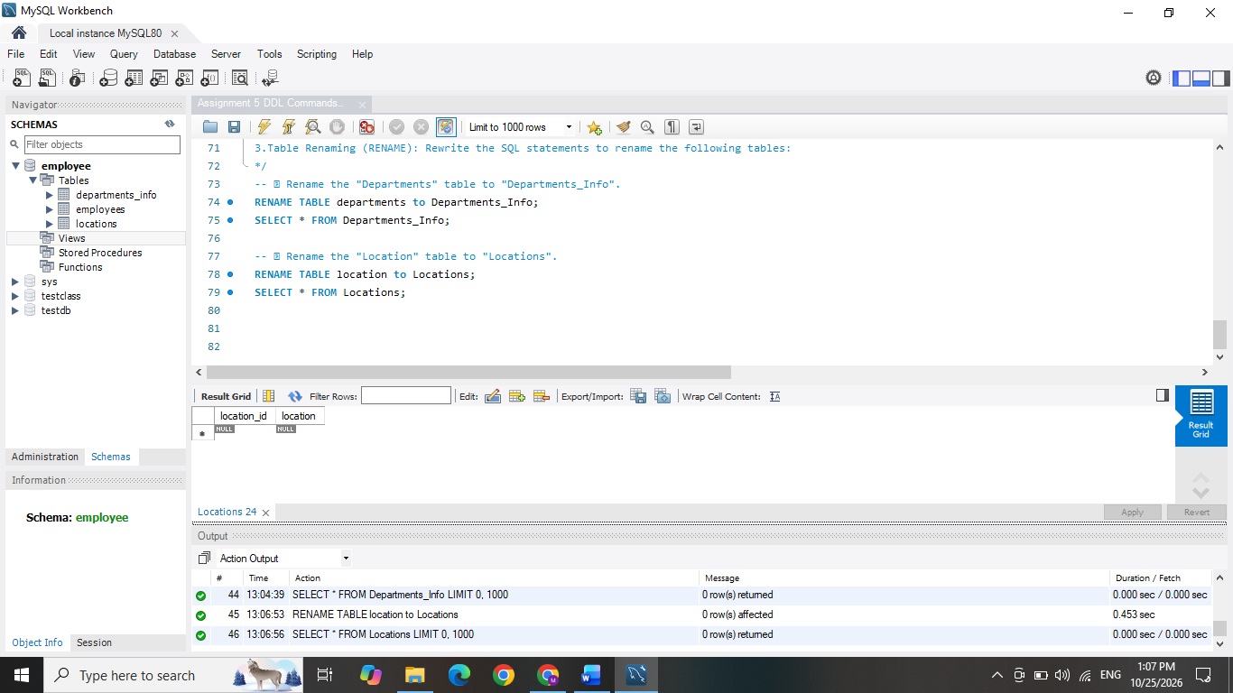

- Table Truncation (TRUNCATE): Write an SQL statement to truncate the Employees table.

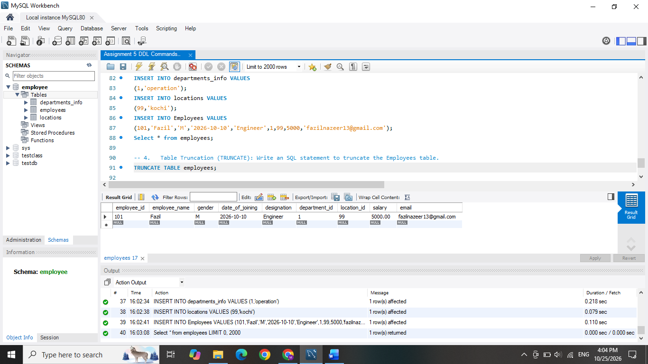
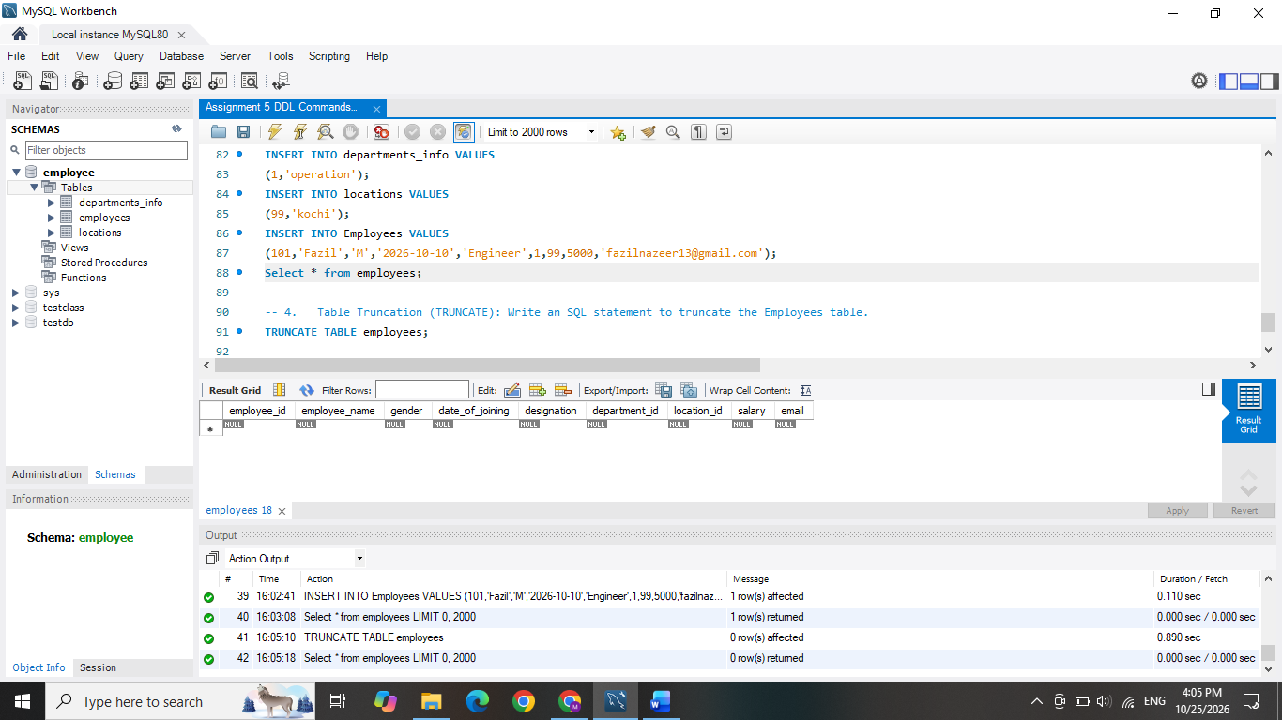

- Database & Table Dropping (DROP): Write the SQL statements to drop the Employees table and then the “employee” database.

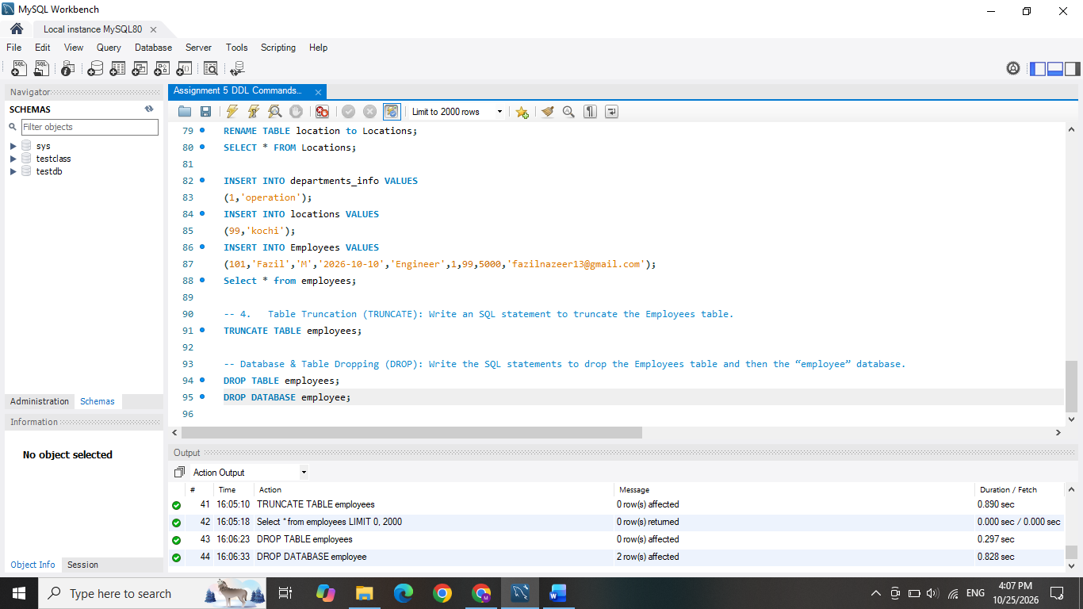

Constraints :
- Database Recreation:
⦿ Drop the 'employee' database if it exists and recreate it using the provided schema, ensuring that all tables are created with the appropriate constraints as instructed.
- Departments Table:
⦿ Ensure that the "department_id" uniquely identifies each department.
⦿ Set up constraints on the "department_name" to avoid duplicate and null entries.
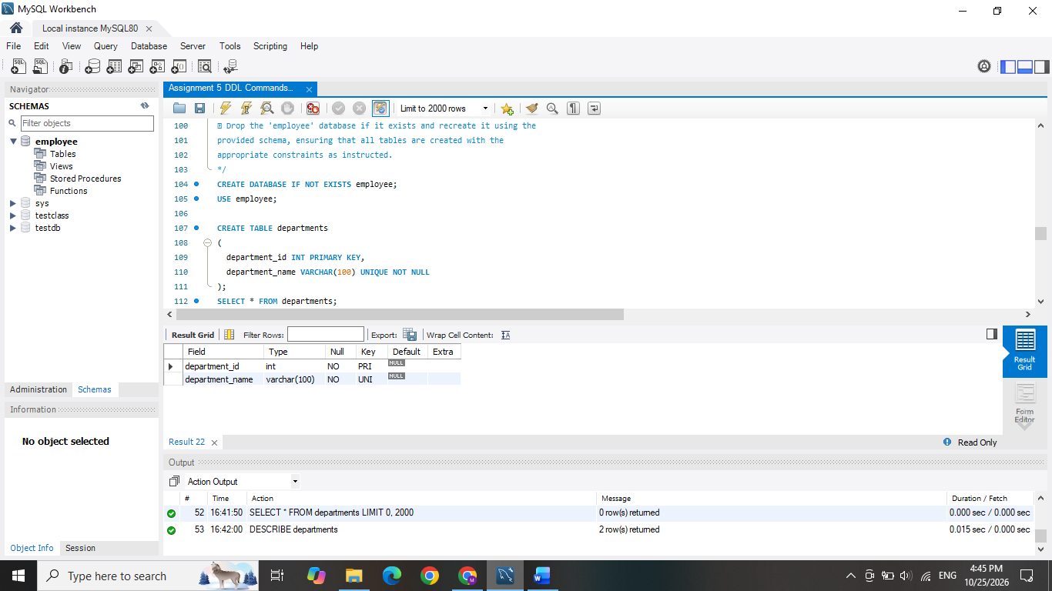

- Location Table:

⦿ Establish a mechanism to automatically generate unique identifiers for each location, ensuring that they are incremented sequentially.

⦿ Implement constraints to prevent the insertion of null and duplicate locations.
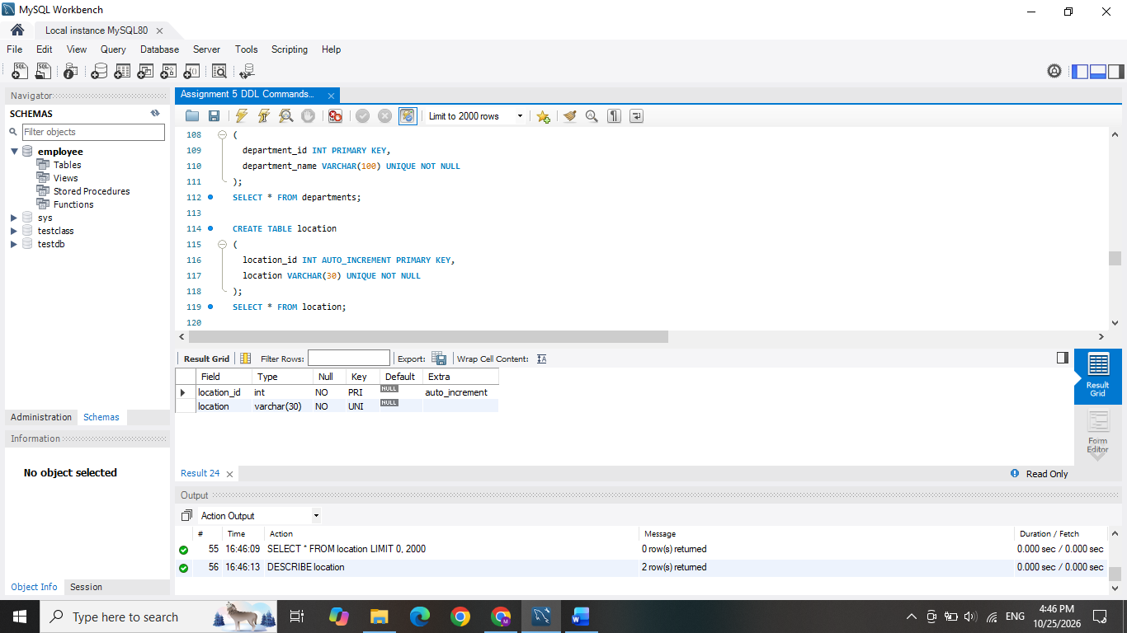
- Employees Table:
⦿ Guarantee that each employee has a distinct identifier.
⦿ Create a restriction to ensure that the employee's name is always provided.
⦿ Limit the acceptable values for the "gender" field to only 'M' or 'F'.
⦿ Enforce a condition to ensure that the employee's age is 18 or above.
⦿ Automatically assign the current date to the "hire_date" field if not specified.
⦿ Establish links between the "department_id" and "location_id" fields in the "employees" table and their respective tables.
